The Development of Early Opera by Monteverdi

Monteverdi was the most prominent musician in the late sixteenth and early seventeenth century from Italy. He was a composer whom mastered most of the major musical genres of the Baroque period and a pioneer in the development of early opera of the period. Earning the reputation as the creator of modern music of his era was due to his creation in new aesthetic and stylistic ideas for the musical Baroque. Monteverdi experimented and developed powerful ways of expressing and structuring musical drama in his operas for Mantua and Venice, especially his L’Orfeo. In fact, the composers of early opera had started using most of contemporary models, such as, forms, musical styles, and compositional techniques. Monteverdi’s L’Orfeo was not the first opera ever written, but is the most significant early opera to have been written. This essay will be focused on Monteverdi’s L’Orfeo and the crucial importance of it towards the development of early opera.

L’Orfeo is known to be the most important in early opera because of its basis on seconda pratica, which is one of the factors for the development of early opera. Monteverdi distinguished between the prima pratica and seconda pratica, also known as the older style and the modern style. The prima pratica refers to early Baroque music which is the stricter style of Palestrina and his Roman contemporaries. On the other hand, the seconda pratica refers to more freedom from the limitations of the older style, and emphasized the meaning of the text by music. For example, the unprepared dissonance, word painting with the notes, and the change of tonality for the text.

The text of ‘Ahi sventurato amante’ in Act 3, has shown a good example of the unprepared dissonance. In last line of the text ‘Rendetemi’l mio ben, Tartarei Numi.’ (Give me back what is mine, Gods of Tartarus.), the note ‘F♯’ in vocal line against ‘E♭’ in base line on setting of the word ‘Tartarei’(Tartarus), which is the Underworld. Besides that, another example is shown in the text of messenger in Act 2. In the very first line when messenger starts singing ‘Ahi caso acerbo, ahi fato empio e crudele’ (Ah bitter fate, ah wicked and cruel destiny), the note ‘G♯’ in vocal line clashes with ‘A’ on setting of the word ‘Acerbo’ (bitter).

Figure 1 Monteverdi, L’Orfeo, Act 3, Orfeo’s ‘Ahi sventurato amante’
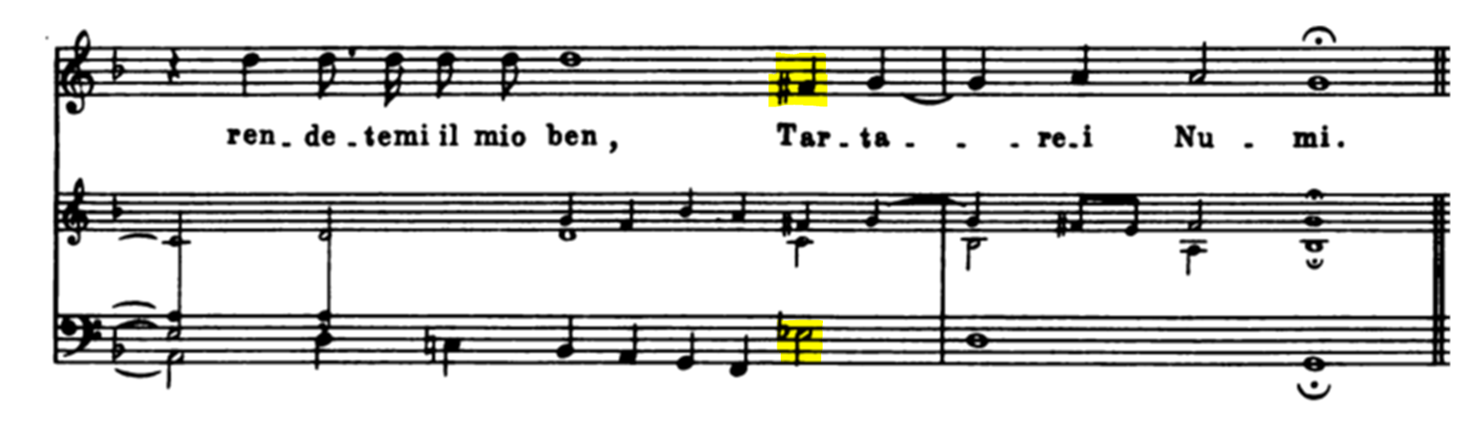
Figure 2 Monteverdi, L’Orfeo, Act 2, Messenger’s ‘Ahi caso acerbo’
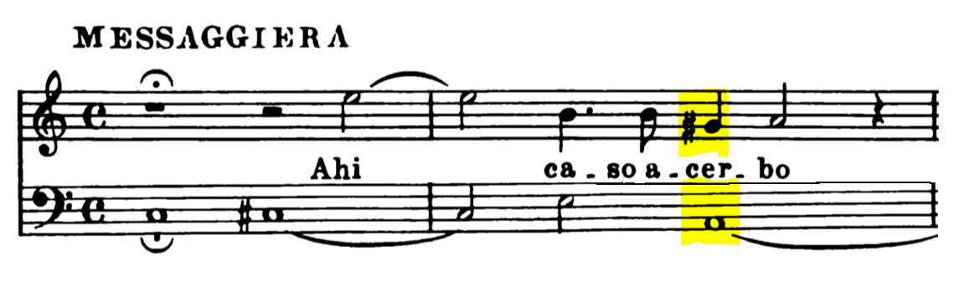

The seconda pratica was about emphasizing the meaning of words as well as using word painting, which is the musical technique of writing music that reflects the meaning of texts. The monologue of Orfeo’s ‘Tu se’ morta’ in Act 2 is the perfect example for showing word painting. For instance, the words ‘più profondi abissi’ (the deepest abysses) and ‘compagnia di morte’ (the company of death) used descending melodic line to describe how strong the words are. In addition, the words ‘stelle’ (stars), ‘Cielo’ (Heaven), ‘Sole’ (Sun) are setting as higher notes whereas the word ‘morte’ (death) set as the lowest note.
Figure 3 Monteverdi, L’Orfeo, Act 2, Orfeo’s ‘Tu se’ morta’
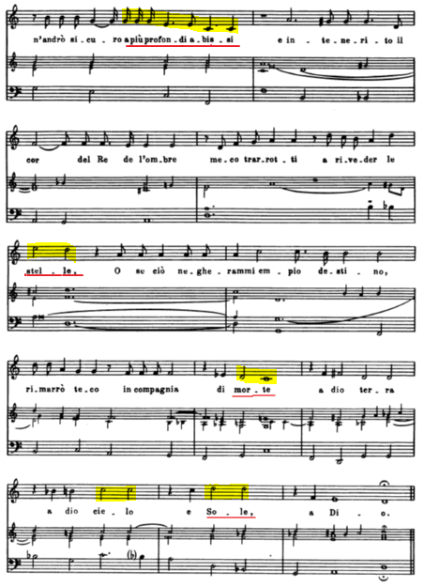
The change in tonality for the text is another example for seconda pratica. The sensitive use of tonality, modulations, and dissonance reflects the semantic and affective aspects of the text. In the scene where Orfeo believed that Euridice is following him in Act 4. The tonal area of D major is representing Euridice, and E major, A major or A minor to death or the Underworld. When Orfeo finally sees his wife, he sings for a phrase in his own G minor and then change to D major when he saw Euridice’s eyes. In the final singing of Euridice in the scene, she sings on Orfeo’s G minor, however her line twists round to E major on the first line ‘vista troppo dolce’ (Ah, too sweet). At final line, the word ‘consort’ (consorte) she arrives at Orfeo’s G minor.

Figure 4 Monteverdi, L’Orfeo, Act 4, the scene Orfeo sees Euridice.
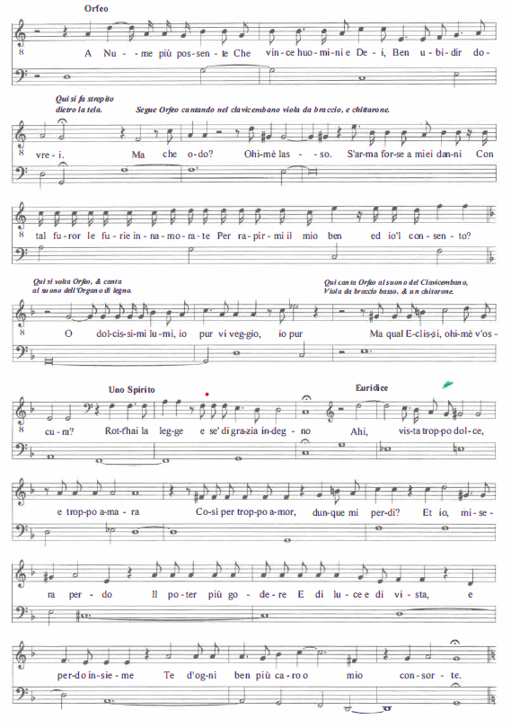
As written and seen, the seconda pratica is the most important factor to the development of early opera. However, the strophic models in L’Orfeo is another notable factor to talk about. Strophic form is a simple way of structuring music based on the repetition of a single section; it is the musical analogue of repeated stanzas in libretto. Monteverdi carefully used strophic models in L’Orfeo, with the consideration of perfectly fitting different types of model. There are the frequent strophic settings and strophic variations in some parts, such as ‘Vi ricorda, o boschi ombrosi’ in Act 2, the prologue, and especially Orfeo’s ‘Possente spito’ in Act 3.

The first type of the strophic model is dance-like strophic arias. The feature of this type is a more freely handled declamation model over a repeated bass, the type that was used since the fifteenth century. The aria ‘Vi ricorda, o boschi ombrosi’ in Act 2 is a triple-time dance song on the model. Moreover, it repeated the same melody and bass with different words, which reflects the form of strophic. In fact, Monteverdi applied this type of model in other works before L’Orfeo.

The strophic-variation arias are another type of the strophic model, which has a more improvisatory practice in the music. In the prologue and ‘Possente spito’ in Act 3, shows the standard improvisation formulas such as using stock melodic-harmonic progression as a basis for declamatory and ornamental singing. Interestingly, Monteverdi composed two versions of the aria ‘Possente spito’, one of which is simple and another, difficult; as amateurs are not able to sing the virtuosic version, and another reason being that he wrote it for singers who wished to improvise by themselves.

The instrumentation of L’Orfeo is another significant factor to mention. It is divided into three main groups; strings, brass, and basso contimuo. The instruments are used for musical characterization of the situation and some characters in the sixteenth century tradition of the musical theater. The instrumentation of L’Orfeo is like of the tradition, however Monteverdi provided the instruments that were required in the score, furthermore there are points in the score where Monteverdi gives information on the use of the instruments, and they were quite new to the period of the time. The figure below shows what Monteverdi wrote in regards to specific instruments, which were required for each character of L’Orfeo.

Figure 5 Monteverdi, L’Orfeo, required instruments list.
According to the list, Monteverdi used 2 harpsichords, 2 double basses, 10 strings from the string family, a double harp, 2 French violins, 2 chitarroni, two organs with wooden pipes, three cellos, four trombones, one regal, two cornets, a sopranino recorder, a long trumpet, and 3 muted trumpets.

Besides the characters, Monteverdi also arranged different instruments for different places. The pastoral first act is represented by the strings, harpsichords, harp, organs, recorders and chitarroni. Whereas the rest of the instruments, mostly brass instruments, are associated with the Underworld, with strings also appearing on several parts in the Hades scenes.

In addition, Monteverdi used instruments in specific places to create deliberate spatial effects. For example, the ritornello of Orfeo’s ‘Vi ricorda o boschi ombrosi’ is marked ‘di dentro’ (invariable) and at the beginning of Act V is marked two ‘organi di legno’ (organs with wooden pipes) and two chitarroni. The instruments in L’Orfeo, shows the function of characterizing different contexts and dramatic situation, such as toccatas, ritornellos, and sinfonias within the musical architecture.

In conclusion, Monteverdi as the most prominent composer of the period, contributed tremendously in the developments for the early opera. Monteverdi’s L’Orfeo is the perfect opera to show the developments he did. As we can see from the essay, the main factor of development was the seconda pratica, which its practice had influenced other baroque composers such as Lully, Dowland, and Purcell. In fact, Monteverdi had an argument with Artusi about the modern treatment of dissonance in music, which is why he distinguished between the prima pratica and seconda pratica. Furthermore, the most important model in L’Orfeo is the strophic models, which were frequent with instrumental sections between the stanzas, as can be seen in the musical structure of L’Orfeo, where Monteverdi enhanced it by applying the use of the strophic models. Lastly, Monteverdi was also extremely specific about his instrumentation in specific parts, he did so with the aim of pursuing the effects he desired.

Bibliography
Online Articles
- Carter, Tim and Chew, Geoffrey: ‘Monteverdi, Claudio’, Grove Music Online (Oxford University Press, 2001), accessed 14 October 2017, http://www.oxfordmusiconline.com/subscriber/article/grove/music/44352#S44352.
- Carter, Tim and Chew, Geoffrey: ‘Monteverdi, Claudio: Theoretical and aesthetic basis of works’, Grove Music Online (Oxford University Press, 2001), accessed 19 October 2017, http://www.oxfordmusiconline.com/subscriber/article/grove/music/44352pg4#S44352.4.
- Tilmouth, Michael: ‘Strophic’, Grove Music Online (Oxford University Press, 2001), accessed 28 Oct 2017, http://www.oxfordmusiconline.com/subscriber/article/grove/music/26981

Books
- Ossi, Massimo and Steinheuer, Joachim: Orfeo (1607), The Cambridge Companion to Monteverdi, ed. Whenham, John and Wistreich, Richard (Cambridge: Cambridge University Press, 2007)
- Carter, Tim: Orfeo (1607), Monteverdi’s Musical Theatre (New Haven: Yale University Press, 2002)

Music score
- Monteverdi, Claudio: L’Orfeo, SV 318 (Vienna: Universal Edition)

English translation of Libretto
- Striggio, Alessandro: L’Orfeo’s Italian Libretto, trans. Blin, Gilbert

Carter, Tim and Chew, Geoffrey: ‘Monteverdi, Claudio’, Grove Music Online (Oxford University Press, 2001), accessed 14 October 2017, http://www.oxfordmusiconline.com/subscriber/article/grove/music/44352#S44352.
Ibid.
Ossi, Massimo and Steinheuer, Joachim: Orfeo (1607), The Cambridge Companion to Monteverdi, ed. Whenham, John and Wistreich, Richard (Cambridge: Cambridge University Press, 2007), 119-140 (p.120).
Carter, Tim and Chew, Geoffrey: ‘Monteverdi, Claudio: Theoretical and aesthetic basis of works’, Grove Music Online (Oxford University Press, 2001), accessed 19 October 2017, http://www.oxfordmusiconline.com/subscriber/article/grove/music/44352pg4#S44352.4.
Ibid.
Ibid.
Ossi, Massimo and Steinheuer, Joachim: Orfeo (1607), The Cambridge Companion to Monteverdi (Cambridge: Cambridge University Press, 2007), 119-140 (p.120).
Ibid, 129.
Ibid.
Ossi, Massimo and Steinheuer, Joachim: Orfeo (1607), The Cambridge Companion to Monteverdi (Cambridge: Cambridge University Press, 2007), 119-140 (p.131).
Ibid.
Tilmouth, Michael: ‘Strophic’, Grove Music Online (Oxford University Press, 2001), accessed 28 Oct 2017, http://www.oxfordmusiconline.com/subscriber/article/grove/music/26981
Ossi, Massimo and Steinheuer, Joachim: Orfeo (1607), The Cambridge Companion to Monteverdi (Cambridge: Cambridge University Press, 2007), 119-140 (p.140).
Ibid, 134.
Carter, Tim: Orfeo (1607), Monteverdi’s Musical Theatre (New Haven: Yale University Press, 2002), 129.
Ibid, 130.
Ibid.
Ibid.
Ibid.
Ibid.
Ossi, Massimo and Steinheuer, Joachim: Orfeo (1607), The Cambridge Companion to Monteverdi (Cambridge: Cambridge University Press, 2007), 119-140 (p.124).
Ibid.
Ossi, Massimo and Steinheuer, Joachim: Orfeo (1607), The Cambridge Companion to Monteverdi (Cambridge: Cambridge University Press, 2007), 119-140 (p.125).
Ibid.
Ibid.
Ibid, 126.

